# Tutorial: Creating a horizontal WebLogic cluster

## Understanding WebLogic Cluster Concept

A WebLogic Server cluster consists of multiple WebLogic Server instances running simultaneously and working together to provide increased scalability and reliability. A cluster appears to clients to be a single WebLogic Server instance. The server instances that constitute a cluster can run on the same machine, or be located on different machines. You can increase a cluster’s capacity by adding additional server instances to the cluster on an existing machine, or you can add machines to the cluster to host the incremental server instances.

Note: Each server instance in a cluster must run the same version of WebLogic Server.

## Clusters Relationship to the domain

A cluster is part of a particular WebLogic Server domain.

A domain is an interrelated set of WebLogic Server resources that are managed as a unit. A domain includes one or more WebLogic Server instances, which can be clustered, non-clustered, or a combination of clustered and non-clustered instances. A domain can include multiple clusters. A domain also contains the application components deployed in the domain, and the resources and services required by those application components and the server instances in the domain.

In each domain, one WebLogic Server instance acts as the Administration Server—the server instance which configures, manages, and monitors all other server instances and resources in the domain. Each Administration Server manages one domain only. If a domain contains multiple clusters, each cluster in the domain has the same Administration Server.

Note: All server instances in a cluster must reside in the same domain; you cannot “split” a cluster over multiple domains. Similarly, you cannot share a configured resource or subsystem between domains.

## Benefits of Clustering

* Scalability
* High-Availability
* Application Failover
* Server Migration
* Load balancing

## Before Beginning

This tutorial will require the following:

* 2 separate or virtual machines running windows XP or higher(Windows Server 2008 R2 is used in the tutorial)
* Network connection with static IP addresses assigned to each machines.
* Java Development Kit (JDK) 1.7 or higher installed on the system (jdk-8u25 is used in the tutorial).
* Zip distribution with Oracle WebLogic Server only and intended for WebLogic Server development only.

The following is a graphical representation of the Cluster that will be created in the tutorial.

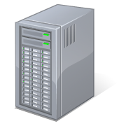

mydomain

**Hostname:**

CMBTEC14.corpnet.ifsworld.com

**IP Address:** 10.17.72.248

**WebLogic Servers:**

myserver(admin)

Listening Port: 7001

Managed-1

Listening Port: 8001

**Hostname:**

CMBTEC14.corpnet.ifsworld.com

**IP Address:** 10.17.72.248

**WebLogic Servers:**

Managed-2

Listening Port: 7001

Managed-3

Listening Port: 8001

Note: Host names, IP addresses will not be the same on your configuration.

## Steps to follow

The tutorial will follow these steps in order and will describe in detail.

1. Pre-requisites
2. Installation of WebLogic Domain
3. Creating the Servers
4. Creating Machines
5. Associating Machines with Servers
6. Cluster the Servers
7. Pack WebLogic Domain
8. Unpacking in the target machine

## Let’s Start

### 1.) Pre-requisites

Main prerequisite for Weblogic is Java Development Kit (JDK).

* Install JDK in the local in the computer that the domain will be created.
* Set JAVA_HOME in the environment variables.(My Computer[right-click]->Properties->Advance System Settings->Advanced[Tab]->Environment Variables->New[under System Variables])

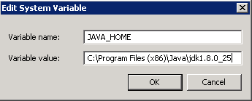

* Then **add** JAVA_HOME\bin to the PATH variable.

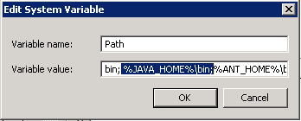

* Unzip the Zip distribution with Oracle WebLogic Server only and intended for WebLogic Server development only (wls1230_dev.zip).

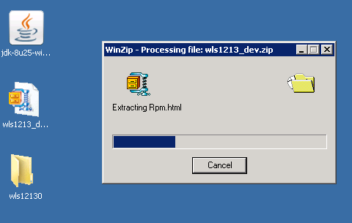

* Copy the wls12130 folder to C:\ drive

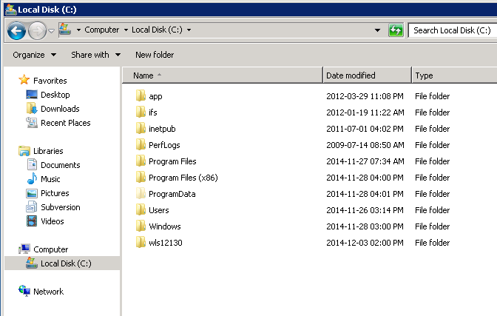

* Set MW_HOME in the environment variables to point to this folder

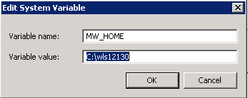

* Run the **configure.cmd** in the folder

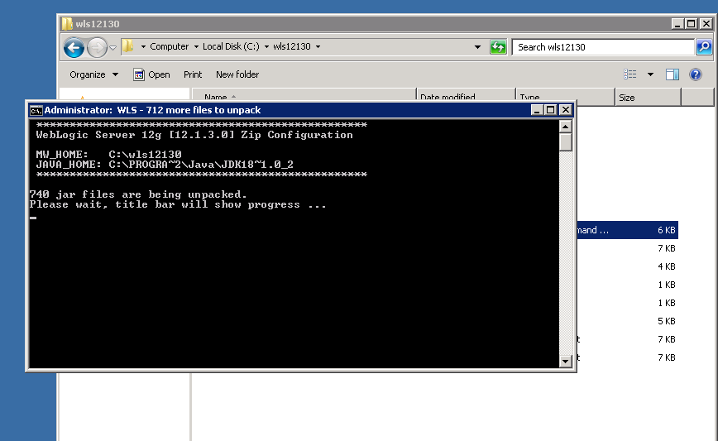

* If prompt for creating domain select **no.**

### 2.) Installation of WebLogic Domain

* Create a folder in to hold the domain. For this create a folder named **mydomain** in C:\
* In command prompt go to the **C:\mydomain** and run the following commands:
  + %MW_HOME%\wlserver\server\bin\setWLSEnv.cmd

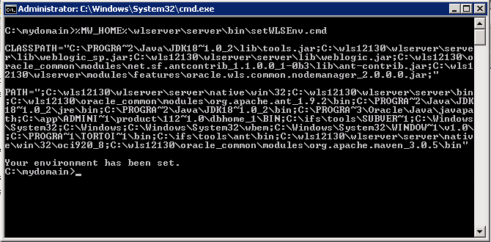

* + %JAVA_HOME%\bin\java.exe %JAVA_OPTIONS% -Xmx1024m -XX:MaxPermSize=256m weblogic.Server

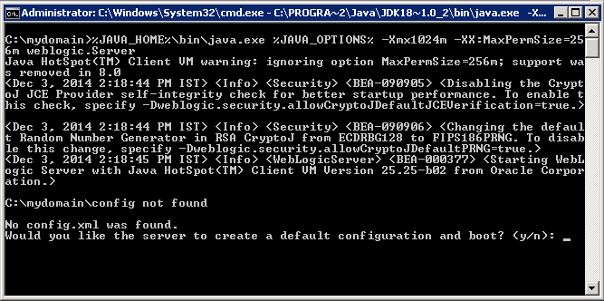

* Select **yes**

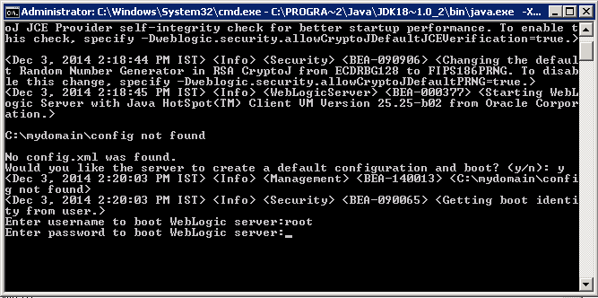

* Give the server administrator a username: root
* Give the server administrator a password. This password should have the following qualities otherwise the installation will throw an exception and interrupt the setup procedure.
  + Uppercase characters of European languages (A through Z, with diacritic marks, Greek and Cyrillic characters)
  + Lowercase characters of European languages (a through z, sharp-s, with diacritic marks, Greek and Cyrillic characters)
  + Base 10 digits (0 through 9)
  + Non-alphanumeric characters: ~!@#$%^&*_-+=`|\(){}[]:;"'<>,.?/
  + Length should be more than 6 characters
* And Re-type the password.
* The Setup will automatically run the WebLogic Server. Or it can be started with **startWeblogic.cmd** in domain directory. Do not close this command prompt; it will kill the WebLogic Server.
* To gain access to GUI of the server open the browser and go to <http://localhost:7001/console>
* Use the administrator’s username and password to get access to the Administration Console

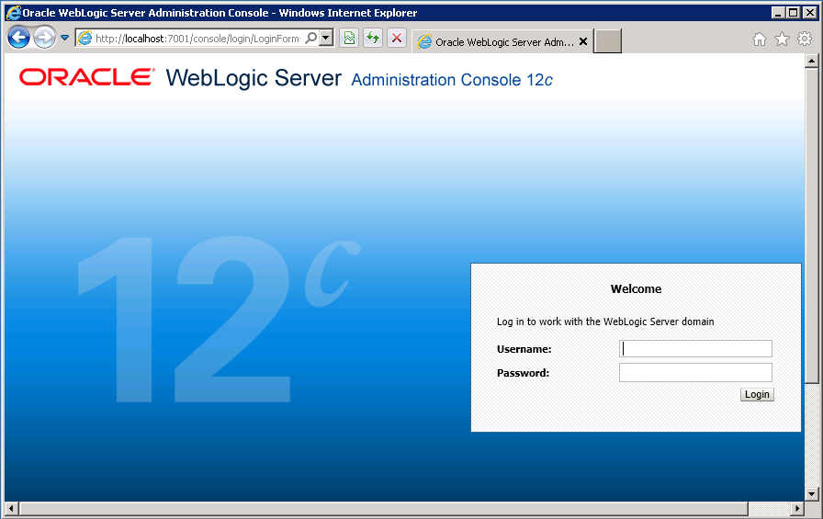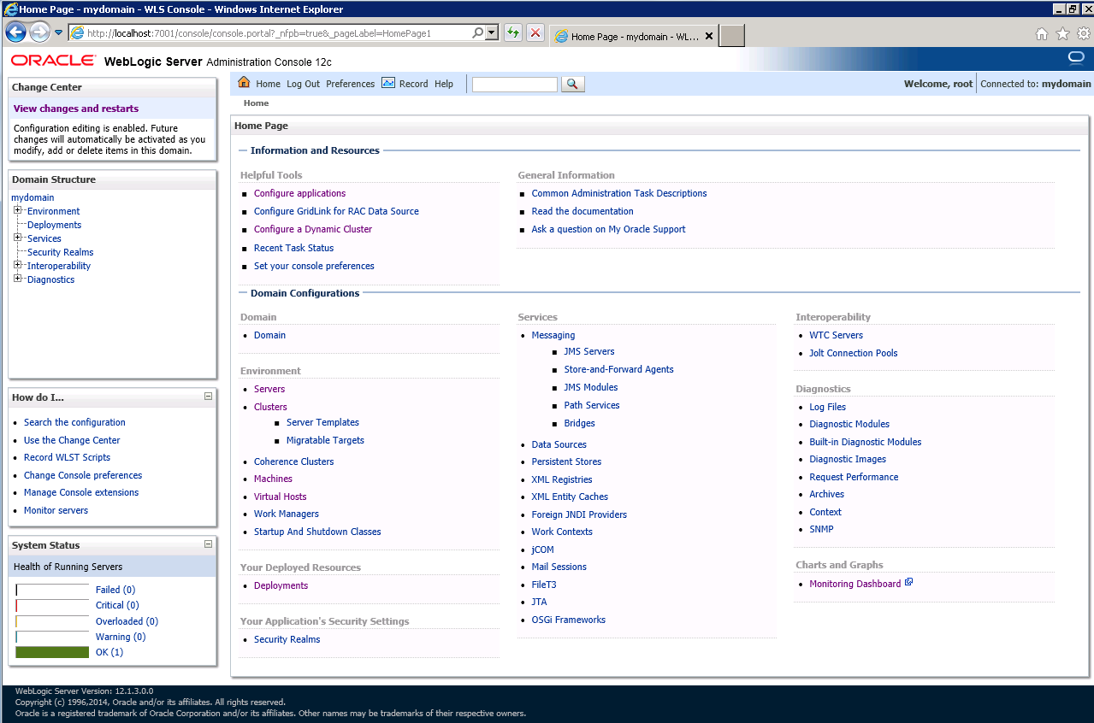

Weblogic Administation Console- all the configuration will be done through this

### 3.) Creating the Servers

* Go to **Servers** under **Environment**, **mydomain** in the Domain Structure

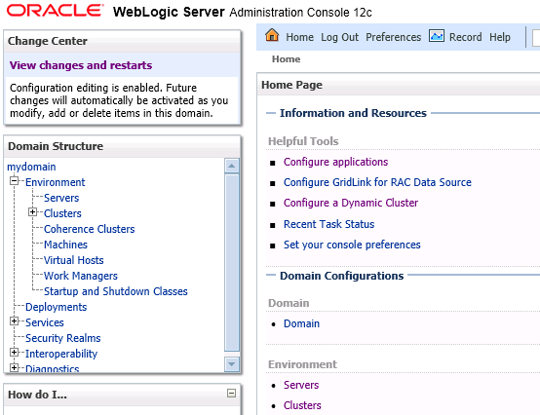

* Summary of Servers will display the server details of the domain. The admin server is already configured, deployed and in RUNNING state.

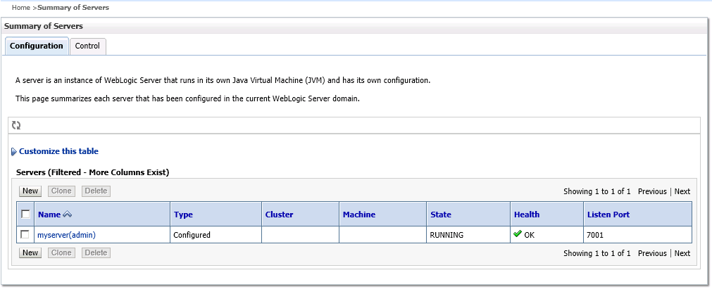

* To create new servers click on **New** button.

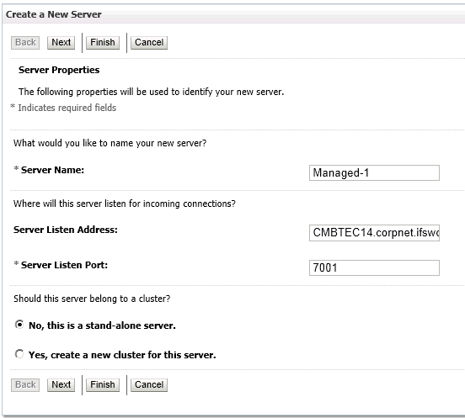

* Give the **Server Name**, a non-conflicting port to the **Server Listening Port** and the hostname of the computer that the server will be resided to the **Server Listen Address**. Select Stand-alone server as the cluster is not yet configured.
* Setup the **Managed-2** and **Managed-3** server with same steps.

Configuration should be as followed:

|  |  |  |
| --- | --- | --- |
| Server Name | Server Listen Address | Port |
| Managed-1 | CMBTEC14.corpnet.ifsworld.com **or** localhost | 8001 |
| Managed-2 | CMBTEC15.corpnet.ifsworld.com | 7001 |
| Managed-3 | CMBTEC15.corpnet.ifsworld.com | 8001 |

* The Summary of Servers should look like the following

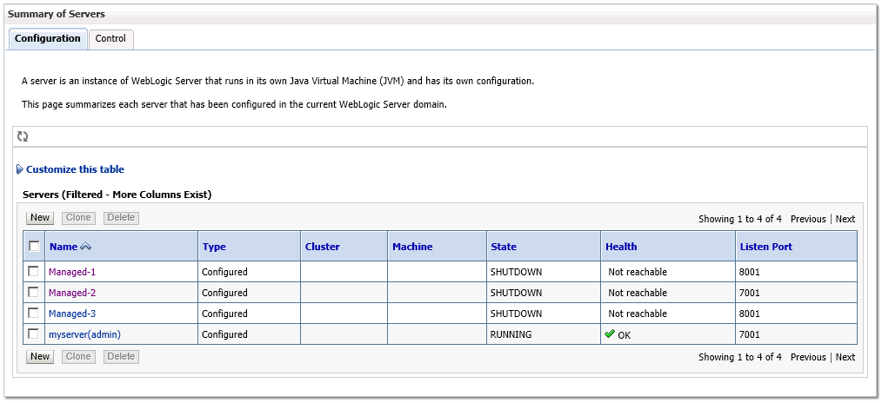

### 4) Creating Machines

* Go to **Machines** under **Environment**, mydomain in the **Domain Structure**

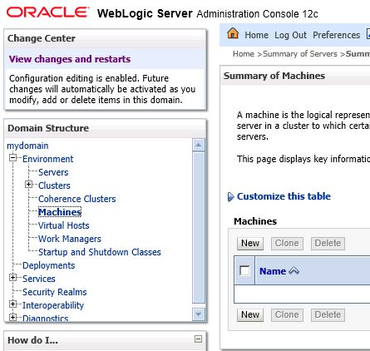

* Summary of Machines will be displayed

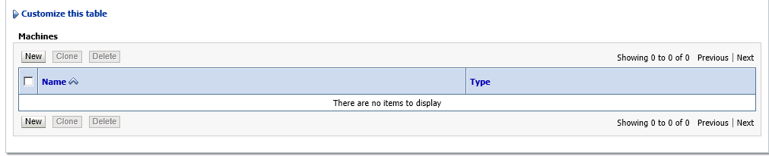

* Click on the **New** button to add the two machines (Individual Computers).
* Give the machine a **Name,** Select Other for Machine OS as this is installed on Windows Server.
* On the next page set the **Type** to SSL. Give the hostname or the IP address of the host to the **Listen Address** and keep the default (5556) port as the **Port**
* Do the same steps to the 2 machines with following configuration**.**

|  |  |  |  |  |
| --- | --- | --- | --- | --- |
| Name | Machine OS | Type | Listen address | Port |
| CMBTEC14 | Other | SSL | CMBTEC14.corpnet.ifsworld.com **or** localhost | 5556 |
| CMBTEC15 | Other | SSL | CMBTEC14.corpnet.ifsworld.com | 5556 |

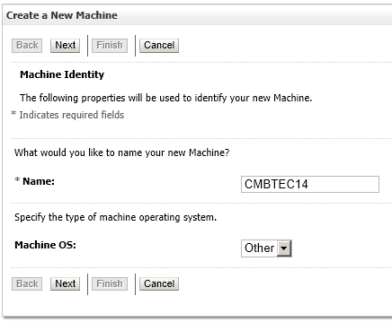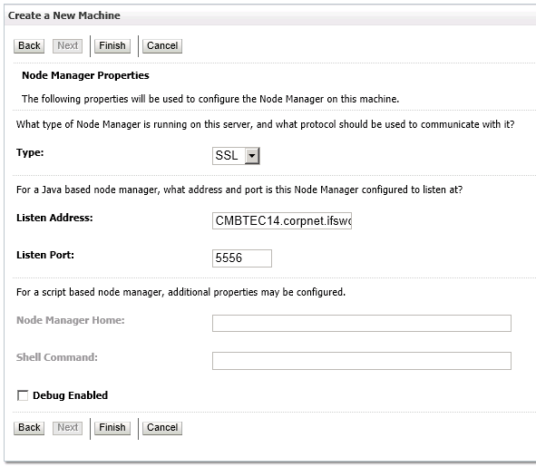

* The **Summary of Machines** will look like this;

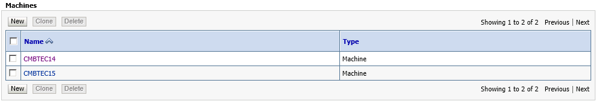

### 5.) Associating Machines with Servers

* Click on a machine in the **Summary of Machines** this will bring up the Settings for the selected machine.
* Under the **Configuration** tab go to **Servers** tab.

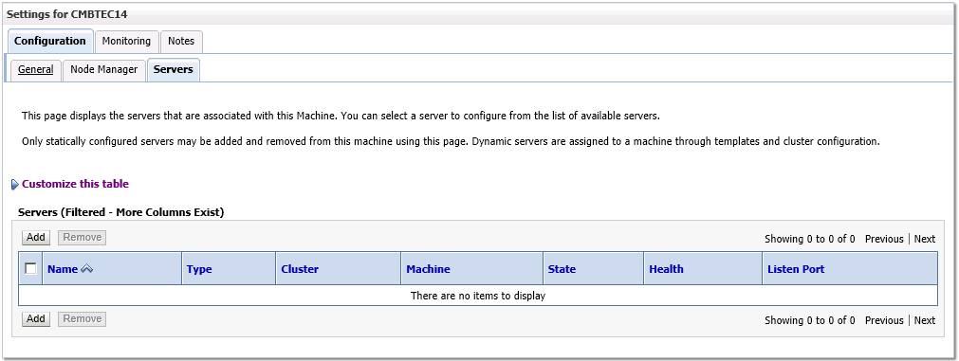

* Click on **Add** to add servers.

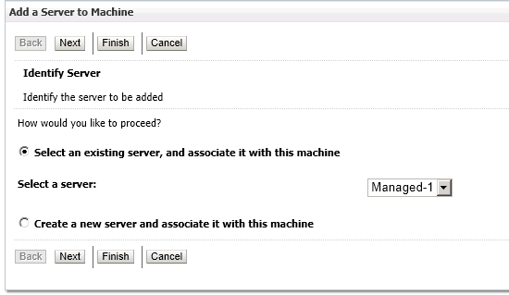

* Repeat the procedure to all the servers.
* The **Summary of Servers** should look like this.

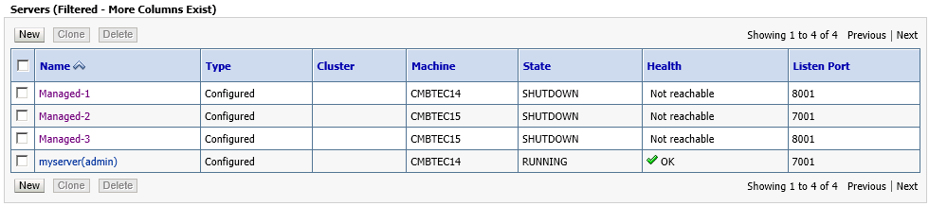

### 6.) Cluster the Servers

* Go to **Clusters** under **Environment**, mydomain in the **Domain Structure**

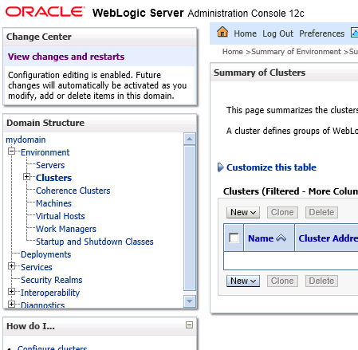

* To add a Cluster to the domain click on **New->Cluster** under the **Summary of Clusters**
* Give a **Name** to the cluster.
* Select **Unicast** as the **Messaging mode** and leave other options in their defaults.

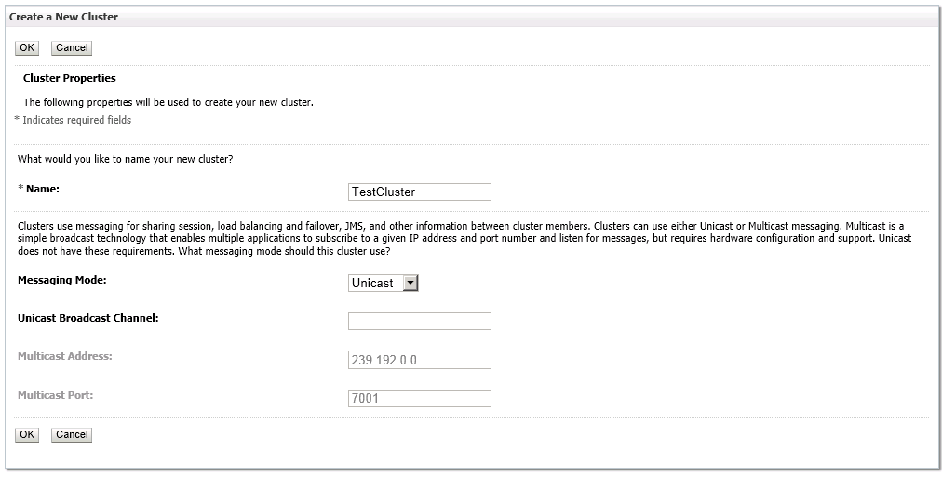

* The Summary of Clusters should now look like this

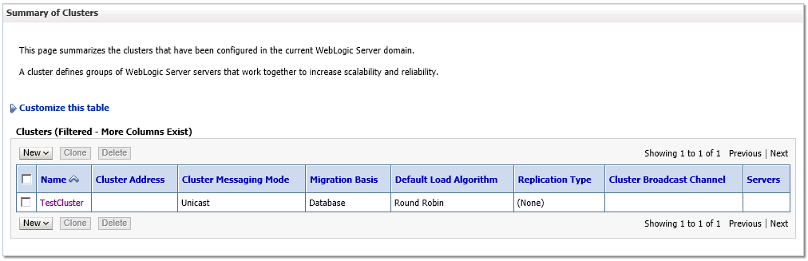

* Click on the Cluster name to go to edit configuration of the cluster.
* Go to the **Servers** tab under the **Configuration** tab.
* In the bottom of the page find the Servers table. (Refer the next figure)

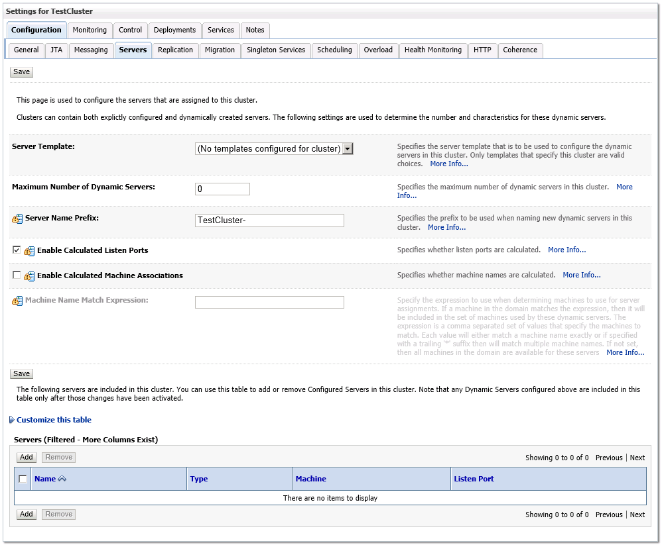

* Click **Add** to add existing or new servers to the cluster.

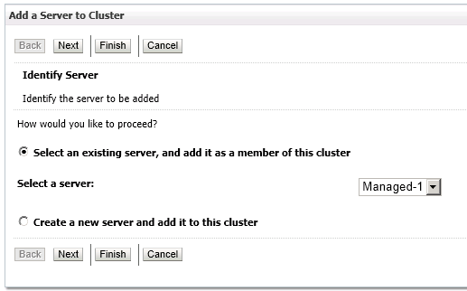

* Select the server and proceed.
* Repeat the process to add all managed servers to the cluster.
* The **Summary of Servers** should look like this

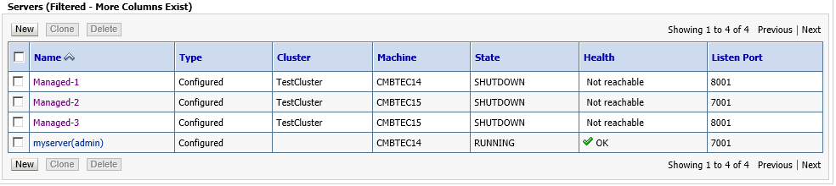

* Now the configuration of the full domain is over.
* It’s time to deploy the domain to the other machine.

### 7.) Pack WebLogic Domain

* Open the **command-prompt** in the **%MW_HOME%\oracle_common\common\bin**
* Run the following command template

pack -managed=true -domain=domain -template=template.jar -template_name="template_name"

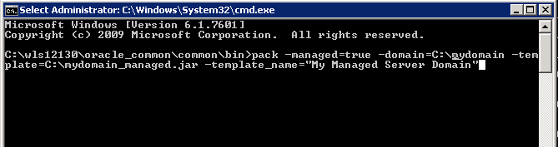

* After Completion find the **mydomain_managed.jar** in **C:\**

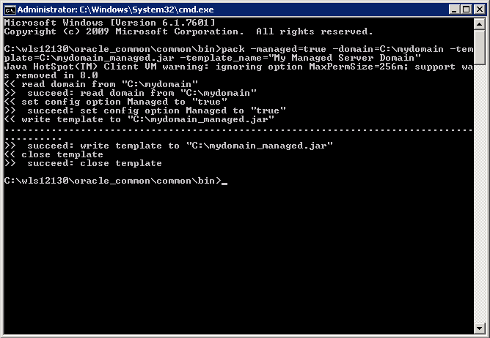

* Copy this file to the target machine of deployment

### 8.) Unpacking in the target machine

* Before unpacking the domain in the target machine, it should be configured with the prerequisits.
* Do the **1.)Pre-requisites** part of this tutorial on the target machine.
* Run the following command template.

unpack -domain=domain -template=template.jar

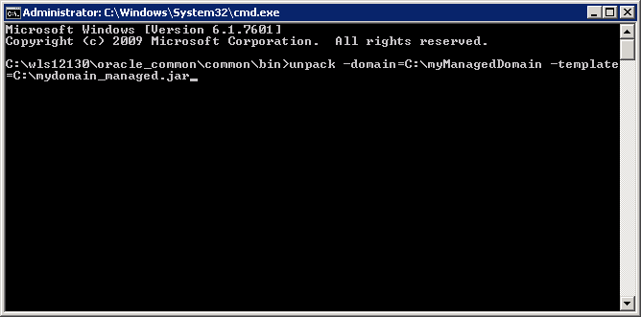

* In order to run and configure managed servers remotely the node manager should be started.
* Go to the **C:\myManagedDomain\bin**
* Run **startNodeManager.cmd**
* Then go to the Administration console of the admin server.
* Go to **Servers** under **Environment**, mydomain in the **Domain Structure**
* Go to Control tab

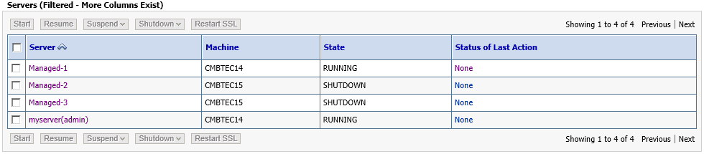

* Select the Servers that need to be started and click **Start**
* View **Summary of Servers** for the status.

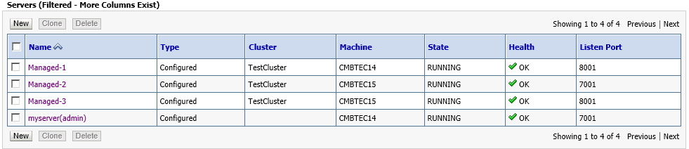

* The Cluster is now up and running!!!